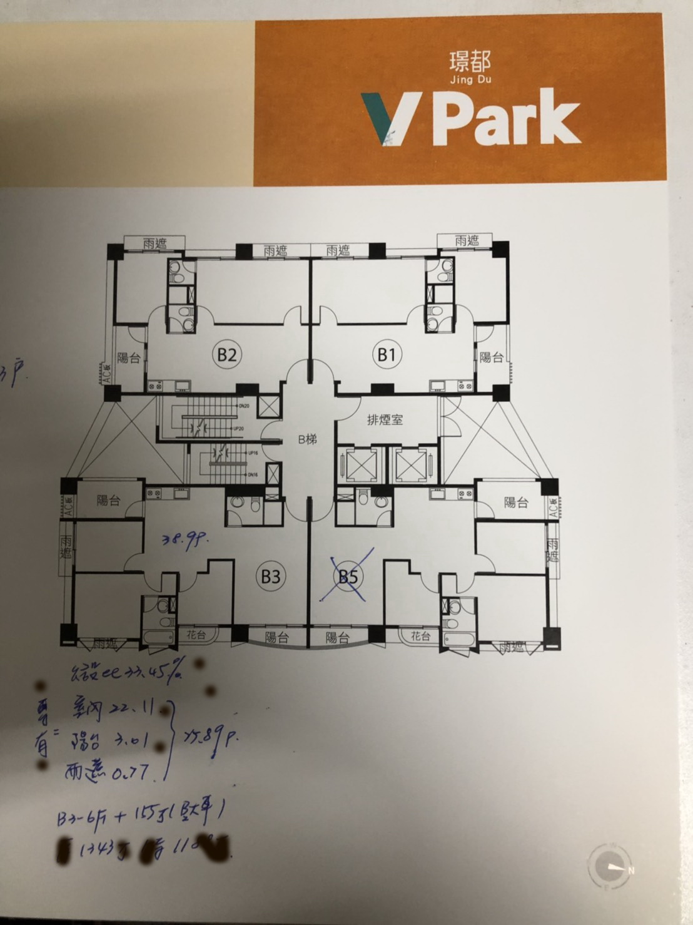
134802-28412-@-青埔高鐵-配置圖-璟都-93戶-3房-40坪-108-10-12

